**Semester 1 (Unit 3) Examination, 2018**

**Question/Answer Booklet**

**MATHEMATICS APPLICATIONS**

**Section One: Calculator-free**

Student Name/Number: ______________________________________________

Teacher Name: ______________________________________________

**Time allowed for this section**

Reading time before commencing work: five minutes

Working time for this section: fifty minutes

**Materials required/recommended for this section**

**To be provided by the supervisor:** This Question/Answer Booklet

Formula Sheet

**To be provided by the candidate:**

Standard items: pens (blue/black preferred), pencils (including coloured), sharpener,

correction fluid/tape, eraser, ruler, highlighters

Special items: nil

**Important note to candidates**

No other items may be taken into the examination room. It is **your** responsibility to ensure that you do not have any unauthorised notes or other items of a non-personal nature in the examination room. If you have any unauthorised material with you, hand it to the supervisor **before** reading any further.

**Structure of this paper**

|  |  |  |  |  |  |
| --- | --- | --- | --- | --- | --- |
| Section | Number of questions available | Number of questions to be answered | Working time (minutes) | Marks available | Percentage of exam |
| Section One: Calculator-free | 6 | 6 | 50 | 50 | 35 |
| Section Two: Calculator-assumed | 11 | 11 | 100 | 100 | 65 |
|  | | | | | 100 |

**Instructions to candidates**

1. The rules for the conduct of these exams are detailed in the *College assessment policy*. Sitting this examination implies that you agree to abide by these rules.
2. Write your answers in this Question/Answer Booklet.

3. You must be careful to confine your responses to the specific questions asked and to

follow any instructions that are specific to a particular question.

1. Supplementary pages for the use of planning/continuing your answer to a question have been provided at the end of this Question/Answer booklet. If you use these pages to continue an answer, indicate at the original answer where the answer is continued, i.e. give the page number.
2. Show all working clearly**.** Your working should be in sufficient detail to allow your answers to be checked readily and for marks to be awarded for reasoning. Incorrect answers given without supporting reasoning cannot be allocated any marks. For any question or part question worth more than two marks, valid working or justification is required to receive full marks. If you repeat any question, ensure that you cancel the answer you do not wish to have marked.
3. It is recommended that you do not use pencil, except in diagrams.
4. The Formula Sheet is not to be handed in with your Question/Answer Booklet.

**Section One: Calculator-free 35% (50 Marks)**

This section has **6** questions. Answer **all** questions. Write your answers in the spaces provided.

Supplementary pages for the use of planning/continuing your answer to a question have been provided at the end of this Question/Answer booklet. If you use these pages to continue an answer, indicate at the original answer where the answer is continued, i.e. give the page number.

Working time: 50 minutes.

**Question 1 (6 marks)**

A sequence can be defined by the following rule:



(a) Display the first 5 terms on the axes provided. (2 marks)

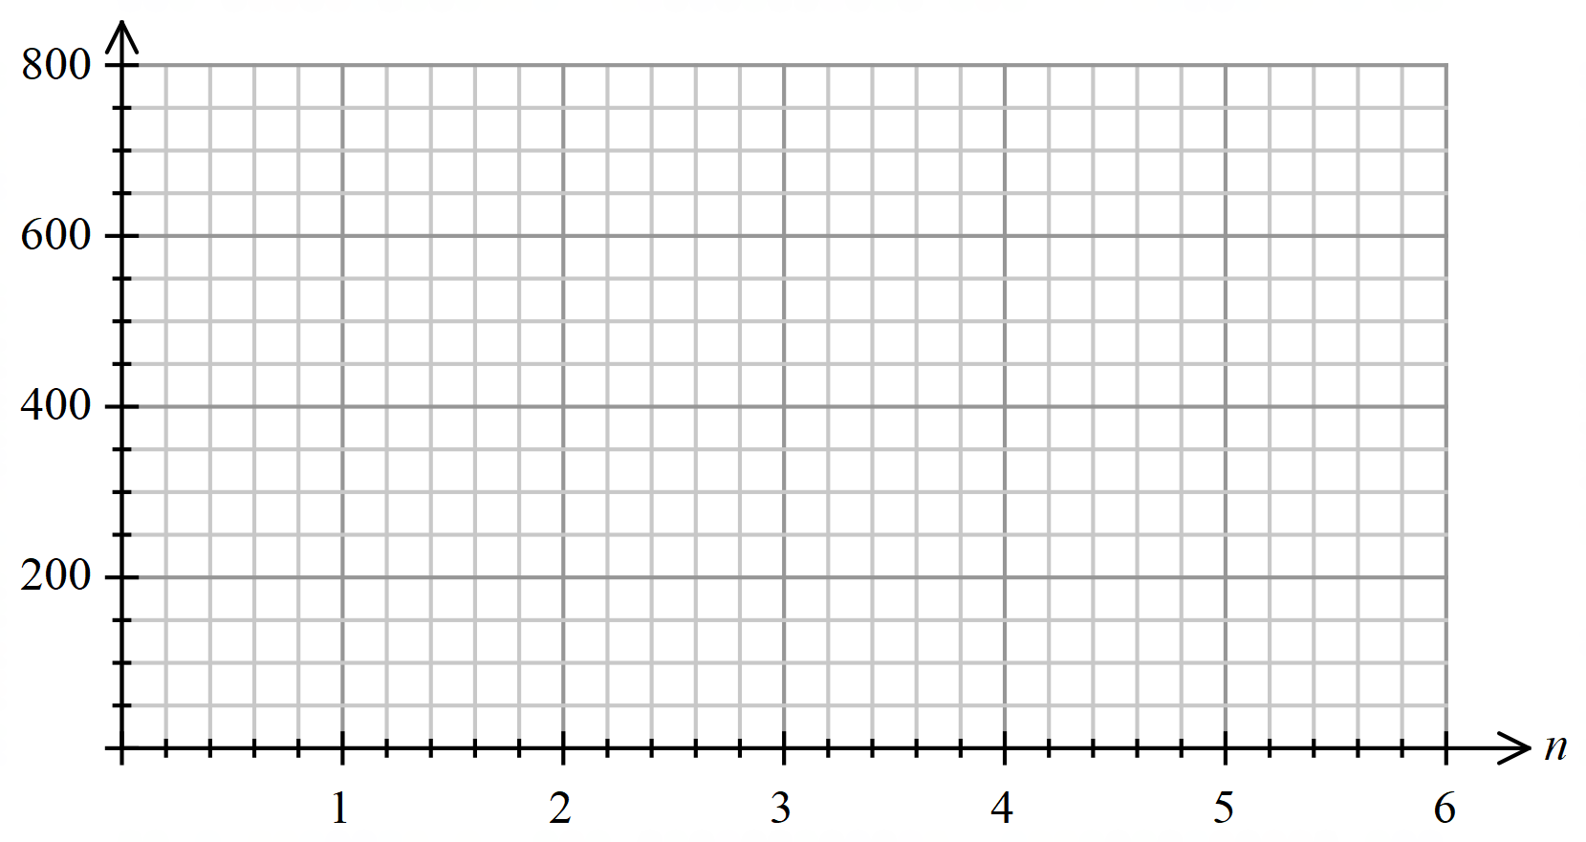

(b) Deduce a rule for the *nth* term of the sequence. (2 marks)

(c) The sequence keeps decreasing. When will *Tn* < 0? Explain. (2 marks)

**Question 2 (10 marks)**

Three separate polls were conducted to collect information about people’s voting preferences just before an election. The results are shown in the table below. People who had not decided how they were going to vote were excluded from the total.

|  |  |  |  |
| --- | --- | --- | --- |
| Party | August 5 | September 15 | October 30 |
| Orange | 36.5% | 39.3% | 41.3% |
| Purple | 3.8% | 4.0% | 4.3% |
| Maroon | 37.5% | 35.9% | 33.4% |
| Violet | 13.4% | 11.9% | 8.6% |
| Brown | 1.3% | 0.8% | 5.5% |
| Other | 7.6% | 8.1% | 6.9% |
| Total | 100.1% | 100% | 100% |

(a) The percentages for the August column do not add up to 100%. Explain. (1 mark)

(b) Determine an appropriate question which could have been used to collect such data.

(1 mark)

(c) Describe an association between two variables in terms of the change in percentages. Clearly indicate the variables and the changes occurring. (2 marks)

(d) The polls were conducted at the same time on each of the three days and over 3000 people were sampled on each occasion. Describe TWO other conditions that are necessary to ensure that these results are comparable. (2 marks)

(e) What would be an appropriate type of graph to display these data? Describe THREE possible features of the graph you would create. (4 marks)

**Question 3 (12 marks)**

The network provided below represent the results when five different players compete against each other. The direction of the arrows indicates the winners and losers, for example, Kam (K) beats Lou (L) and K 🡪 L shows the arrow is pointing from K to L.

Other than Kam and Lou, the players are Mal (M), Pat (P) and Rob (R).

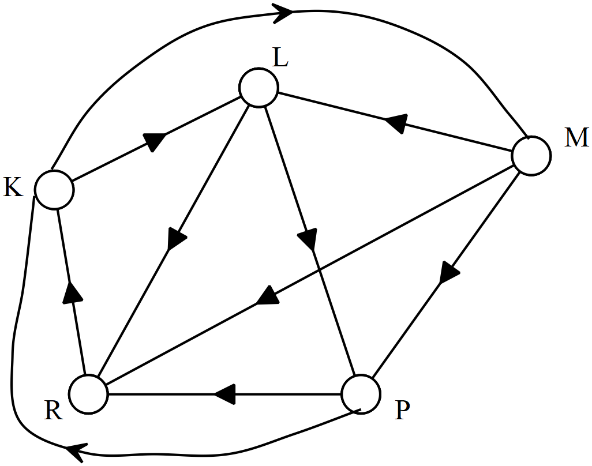

(a) For the network shown

(i) What do the vertices represent? (1 mark)

(ii) What loops are present? Explain your answer. (2 marks)

(iii) Why is it classified as a digraph? (1 mark)

(iv) Every vertex is connected to every other vertex. What is the name given to this type of graph? (1 mark)

(b) Construct the adjacency matrix to represent this graph. (3 marks)

(c) Identify the numbers along the leading diagonal. Explain these numbers.

(2 marks)

(d) Which player has won the most number of times? How can the matrix be used to identify this player? (2 marks)

**Question 4 (11 marks)**

The scatterplot shows the relationship between two variables associated with the weekly costs of running a car. Data are provided for 9 different models of cars.

The equation for the least squares line is given by *y* = 0.15*x* – 0.7 where *y* represents the average weekly cost for tyres and *x* represents the average weekly cost for fuel. The coefficient of determination is 0.687.

(a) What is the direction of the association between the average weekly cost for fuel and the average weekly cost for tyres? (1 mark)

(b) For these cars what is the rise in the average weekly cost of tyres when the average weekly cost of fuel rises by $1? (1 mark)

(c) What percentage of variation in the average weekly cost of the tyres can be attributed to the change in the average weekly cost of the fuel? (1 mark)

(d) Three estimates are given for the correlation coefficient: 0.3 0.6 0.8

Which of these three values is the best estimate? Justify your selection. (2 marks)

(e) Use the equation to predict the average weekly cost for tyres in a car where the average weekly cost for fuel is $50. (2 marks)

(f) Describe the reliability of the prediction that you made in part (e) and justify your conclusion. (2 marks)

(g) For another model of car, the average weekly cost for tyres is $7 and for fuel is $17. Add this point to the scatter diagram. (1 mark)

(h) How would the coefficient of determination change if the data for the car described in part (d) are included in the calculations? Would it increase, decrease or stay the same?

(1 mark)

**Question 5 (6 marks)**

(a) The network below represents the distance (metres) between libraries at a local university. Travelling via libraries determine the shortest path from E to A when no library is visited more than once.

Justify your selected path by showing the distance travelled and the libraries visited for FOUR different paths (including the shortest path). (3 marks)

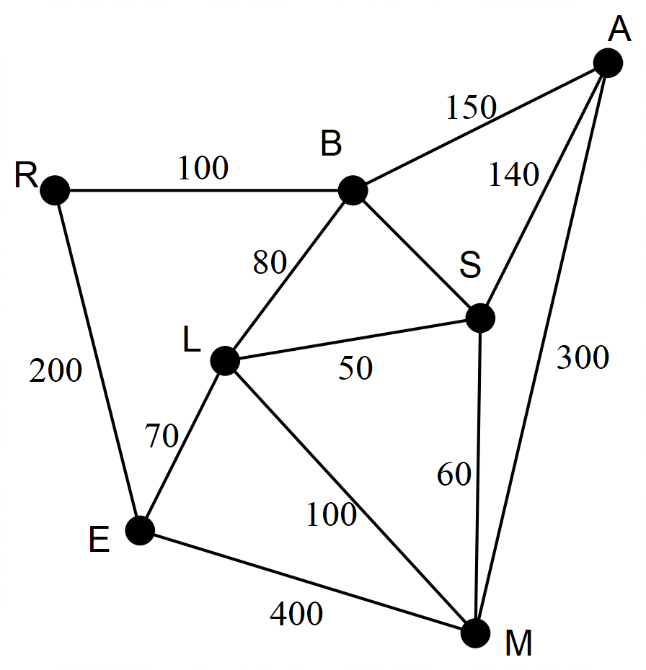

(b) What is the name given to a graph where the distances are marked on the edges?

(1 mark)

(c) Why is the graph described as a simple graph? Give TWO reasons. (2 marks)

**Question 6 (5 marks)**

The population of frogs in a large swamp can be modelled by the following recurrence relation.

 where *n* represents the number of years that have passed.

There were 400 frogs at the end of the first year and after another 3 years the population had fallen to 200.

(a) Use the data supplied to complete the table below. (2 marks)

|  |  |  |  |  |
| --- | --- | --- | --- | --- |
| Years passed | 1 | 2 | 3 | 4 |
| Population |  |  | 274 |  |

(b) Each year the population increases by the same rate and just before the end of the year a number of frogs are removed in an effort to control the population.

(i) How many frogs are removed each year? (1 mark)

(ii) What is the rate at which the population increases each year? (1 mark)

(c) After four years the population has declined to 200. To maintain this number of frogs over the long term, what recurrence relation would model the population if the rate of increase were to remain constant? (1 mark)

**End of Questions**

Additional working space

Question number: __________________

**Acknowledgements**

Data for Question 4 were retrieved from the UNICEF website.

© MAWA, 2018

This examination is Copyright but may be freely used within the school that purchases this licence.

* The items that are contained in this examination are to be used solely in the school for which they are purchased.
* They are not to be shared in any manner with a school which has not purchased their own licence.
* The items and the solutions/marking keys are to be kept confidentially and not copied or made available to anyone who is not a teacher at the school. Teachers may give feedback to students in the form of showing them how the work is marked but students are not to retain a copy of the paper or marking guide until the agreed release date stipulated in the purchasing agreement/licence.

*Published by The Mathematical Association of WA*

*12 Cobbler Place, MIRRABOOKA 6…*